A+ Computer Science SORT TIMER Lab Value - 100

Lab Goal : This lab was designed for you to learn how each sort works, how fast each sort works, and why each sort works.

Lab Description : Generate a list of numbers, sort each list with a different sort, and then output the time it took that sort to sort the list of numbers.

Sample Output :
writing #s to file

loading #s from file

linear Search - O(N)
Seconds taken to find 1: 0.0

loading #s from file

The times you see here are a general idea. Your times will vary depending on the type of PC your run the program on.
Quick Sort - N*LogN
Seconds taken to sort list: 0.031
Binary Search
Seconds taken to find 1: 0.0

loading #s from file

Merge Sort - N*LogN
Seconds taken to sort List: 0.031

loading #s from file

Quick Sort - N*LogN
Seconds taken to sort List: 0.016
BONUS OPTION : Output the sort times as a graphical bar chart.

loading #s from file

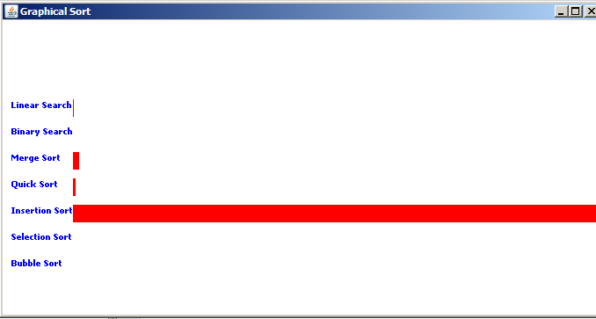
Insertion Sort - N*N
Seconds taken to sort List: 4.64

loading #s from file

Selection Sort - N*N
Seconds taken to sort List: 21.375

loading #s from file

Bubble Sort - N*N
Seconds taken to sort List: 50.235

